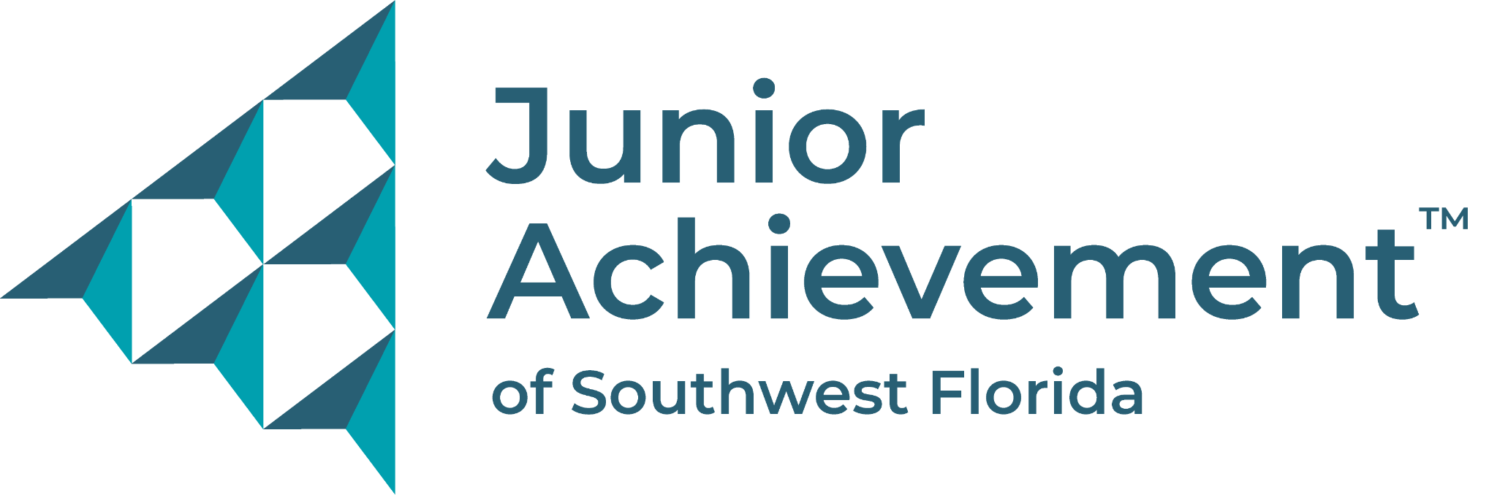
CONTACTS
ORGANIZATION MEDIA
Angela Fisher Josh Milton
Junior Achievement of Southwest Florida CONRIC pr + marketing
239-225-2590 239-690-9840 x1004
afisher@jaswfl.org josh@conricpr.com

FOR IMMEDIATE RELEASE
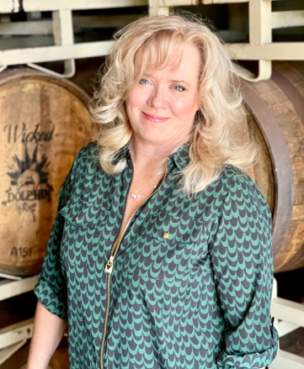
JoAnn Elardo Thomas M. Moran® Mark Stevens
Wicked Dolphin Distillery Moran Wealth Management® Stevens Construction

Junior Achievement announces 2023 Business Hall of Fame Laureates
Distinguished award recognizes influential, visionary business leaders within SWFL
FORT MYERS, Fla. (Feb. 20, 2023) – Junior Achievement of Southwest Florida (JA) announced JoAnn Curtin Elardo, co-founder and President of Wicked Dolphin Distillery, Thomas M. Moran AIF® Chairman, CEO, and CIO of Moran Wealth Management®, and Mark Stevens, President of Stevens Construction, as the 2023 laureates to be inducted into the JA Business Hall Of Fame on Tuesday, April 18, at 5:30 p.m., at the Ritz-Carlton, Golf Resort, in Naples. The prestigious event honors influential, visionary leaders and organizations that have made a significant impact and elevated the educational landscape for local youth regarding financial literacy, entrepreneurship, and work readiness in Southwest Florida.

Elardo’s influence has touched lives across the globe. From Warsaw, Poland, where she opened an award-winning sporting goods retail shop and distribution center that expanded into several countries, to building schools and a medical clinic in the Congo, Elardo has also continuously had a positive impact on Southwest Florida since moving to Cape Coral in 2008. In addition to opening the Cape Coral Animal Shelter and several other philanthropic endeavors, Elardo is the partner of an international distribution company, owns a commercial real estate investment company, and is on the Board of Gulf Coast Business Bank. Elardo has earned several awards and accolades and is best known locally as the founder of Wicked Dolphin Distillery which has also won several awards for its handcrafted spirits.

With more than 30 years of experience in the financial services industry, Moran leads an independent Registered Investment Advisory (RIA) firm with a comprehensive team of more than 35 professionals. Passionate about children’s charities and the arts, he spent 12 years on the board of Youth Haven, while his support of Gulfshore Playhouse includes the new Baker Theatre and Education Center, and the funding of the Moran Main Stage. Tom and his wife Sandi Co-Chaired the Naples Winter Wine Festival twice in support of the Naples Children and Education Foundation. He has received several national and local awards, including the Education Foundation of Collier County’s Men of Distinction, Barron’s Hall of Fame, and the Invest in Others Community Leadership Award recognizing the charitable works of financial advisors. His firm has also sponsored FGCU’s (Florida Gulf Coast University) Bloomberg Research Lab and their continued affiliation with the educational division of Barron's magazine.

Stevens founded Stevens Construction in 2003 and developed a unique construction management process, proven successful by earning 80% of his business from repeat or referred clients. He is a proven leader in the company and throughout the community. Stevens is currently Chair of the Horizon Council, a member of the Horizon Council since 2006 and a board member since 2019, previously serving on the Board of Directors for LBIA, Builders Care, Page Healthcare, Inc., and the Juvenile Diabetes Research Foundation. Stevens has been recognized as an Earn to Learn Mentor of Impact, Gulfshore Business 40 Under 40, News-Press Top Entrepreneur, and Business Observer Entrepreneur of the Year.

Junior Achievement strives to continue to provide life-changing, no-cost programs to students in the Southwest Florida community. Sponsors make a difference in the lives of local students and are recognized in a multitude of ways before, during, and after the event. Current sponsors for the event include presenting sponsor First Horizon Bank, diamond sponsor Title Professionals of Florida, and gold sponsors Assured Guaranty and Rist Family Foundation. Sponsorship opportunities and ticket information are available at https://event.gives/jahof. Inquiries can also be made at (239) 225-2590 or info@jaswfl.org.

JA is the world’s largest organization dedicated to giving young people the knowledge and skills they need to own their economic success, plan for their future, and make smart academic and economic choices. JA programs are delivered by corporate and community volunteers, and provide relevant, hands-on experiences that give students from kindergarten through high school knowledge and skills in financial literacy, work readiness, and entrepreneurship. To help support Junior Achievement of Southwest Florida and our future workforce, please visit www.JASWFL.org or call 239-225-2590.

About Junior Achievement USA®
Junior Achievement is the world's largest organization dedicated to giving young people the knowledge and skills they need to own their economic success, plan for their future, and make smart academic and economic choices. JA programs are delivered by corporate and community volunteers, and provide relevant, hands-on experiences that give students from kindergarten through high school knowledge and skills in financial literacy, work readiness, and entrepreneurship. Today, JA reaches more than 2.5 million students per year in 104 markets across the United States, with an additional 5.2 million students served by operations in 100 other countries worldwide. Junior Achievement USA is a member of JA Worldwide. For more information, visit www.ja.org.

Locally, Junior Achievement of Southwest Florida partnered with classroom business volunteers during the 2021-2022 school year to provide nearly 135,000 hours of instruction to nearly 14,800 students in 589 classes throughout Collier, Lee, and Charlotte counties. For more information on Junior Achievement of Southwest Florida, visit www.JASWFL.org, call (239) 225-2590 or email info@jaswfl.org.

# # #

Attachments:
Logo
Photos

